Colts Fall Classic League – Returning Player Registration

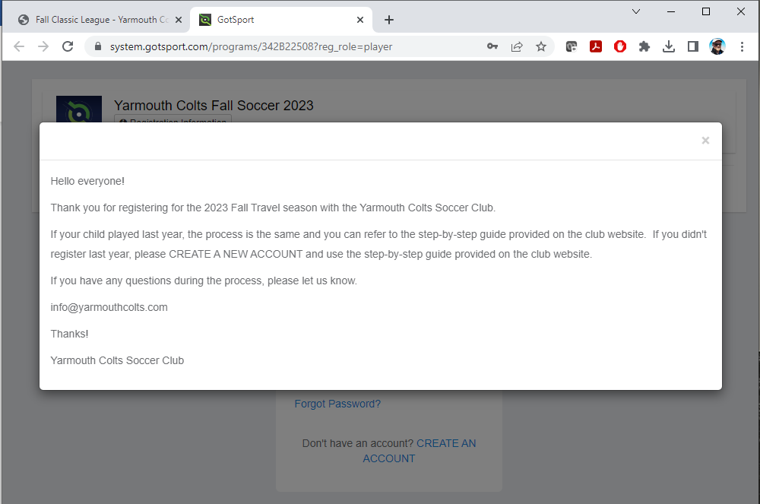
Click on the “x” on the top right of the welcome message to close it and start the registration process.
Enter your user ID and password.
As a returning user, you should see the previous “players”, “coaches”, and “managers” registered using this account.
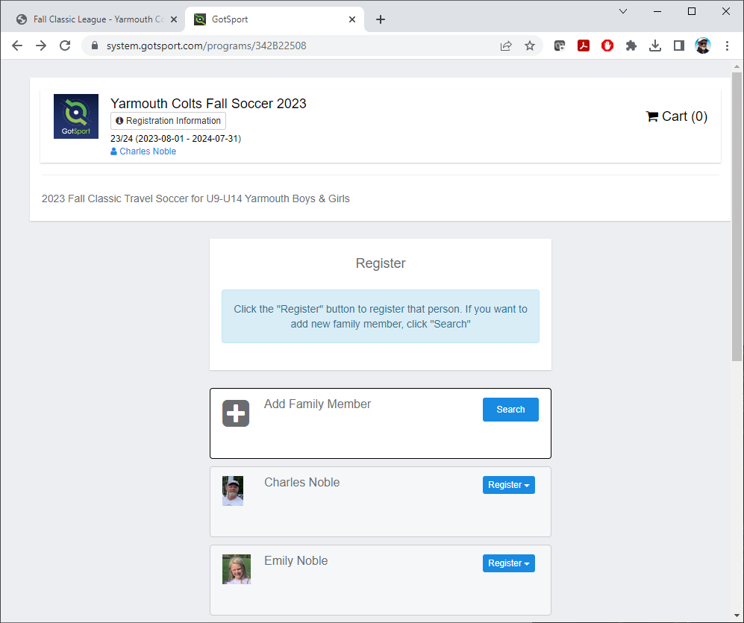
Click on “Register” and the drop-down selection should give you options of “Player”, “Coach”, or “Manager”.
If you need to add a new player, click on “Add Family Member”.
Since this is returning player, verify the existing information is correct, then click “Save” at the bottom left.
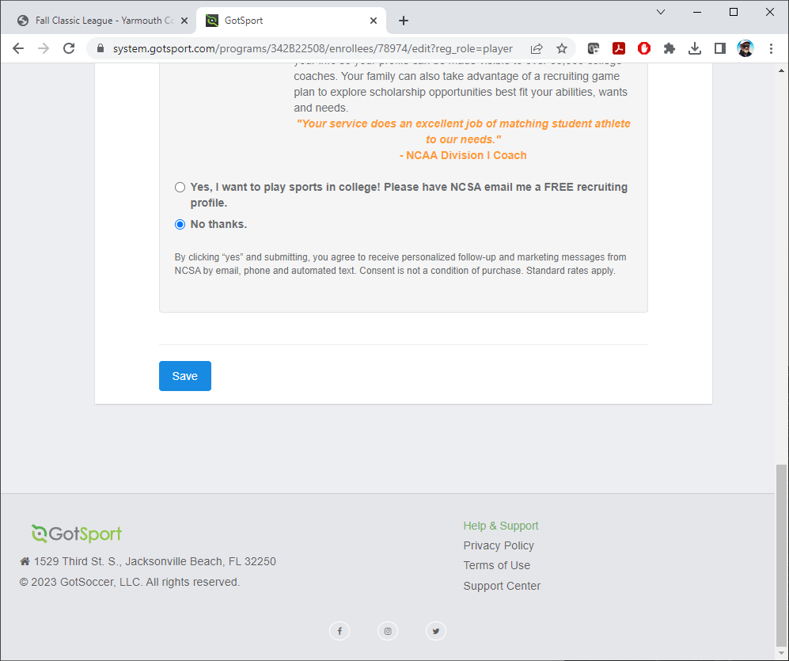
NOTE: YOU MUST CURRENTLY RESIDE IN YARMOUTH IN ORDER TO PARTICIPATE WITH THE YARMOUTH COLTS SOCCER CLUB. THIS IS A RULE BY SOCCER MAINE, THE GOVERNING BODY. IF YOU HAVE ANY QUESTION SURROUNDING YOUR ELIGIBILITY OR SPECIAL CIRCUMSTANCES THAT MAY ALLOW YOU TO RESIDE OUTSIDE OF YARMOUTH AND STILL PARTICIPATE, PLEASE REACH OUT TO THE COLTS REGISTRAR (REGISTRAR@YARMOUTHCOLTS.COM) FOR MORE INFORMATION.
Verify the existing Parents/Guardians and Emergency/Medical Information is accurate and up-to-date.

Click “Continue” on bottom right.
Please enter any special information the Yarmouth Colts Soccer Club may need to know about the player.
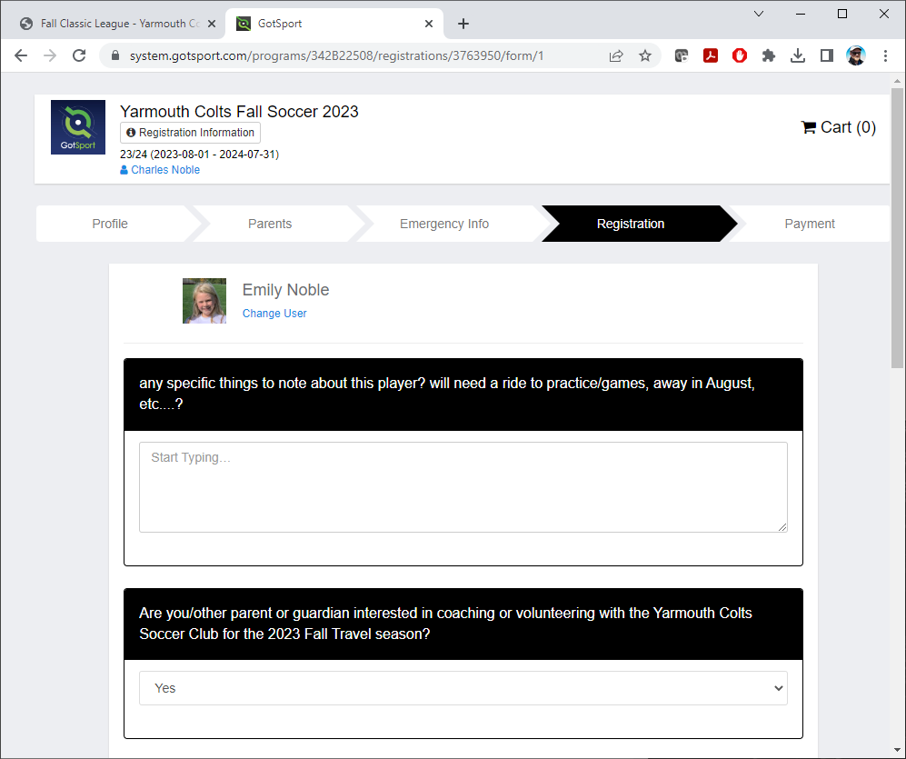
Please electronically sign your name and click “Save (Page 1 of 1)” on bottom right.
Payment information, please click on “Select” to continue.

Click on “Continue to Checkout” to proceed to payment confirmation.
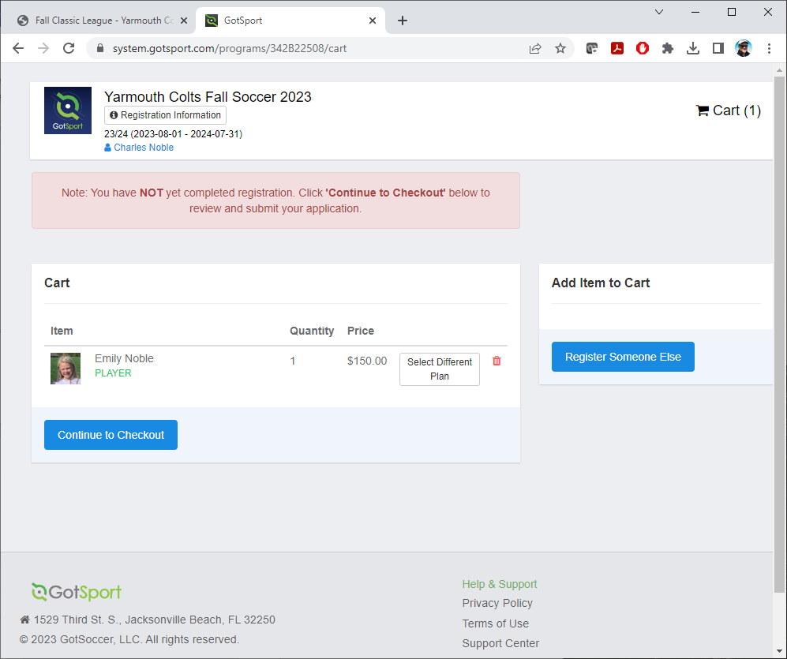
Select the payment method you would prefer, Credit Card or Check/Money Order, enter information, check box “Yes, I agree” and click “Register”….it says “Pay” but once you fill out details, it becomes “Register”
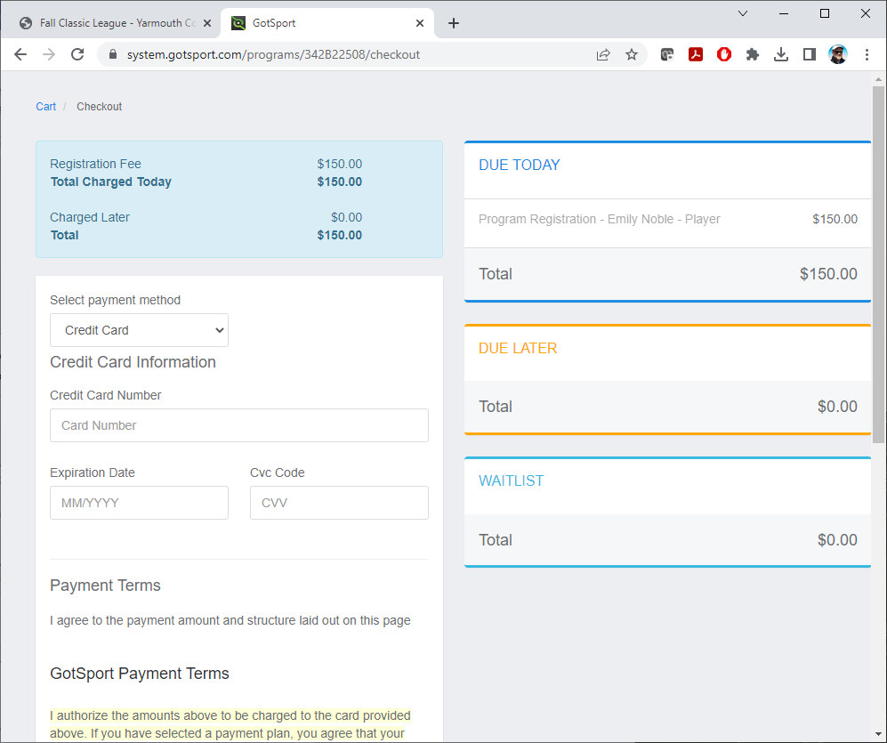
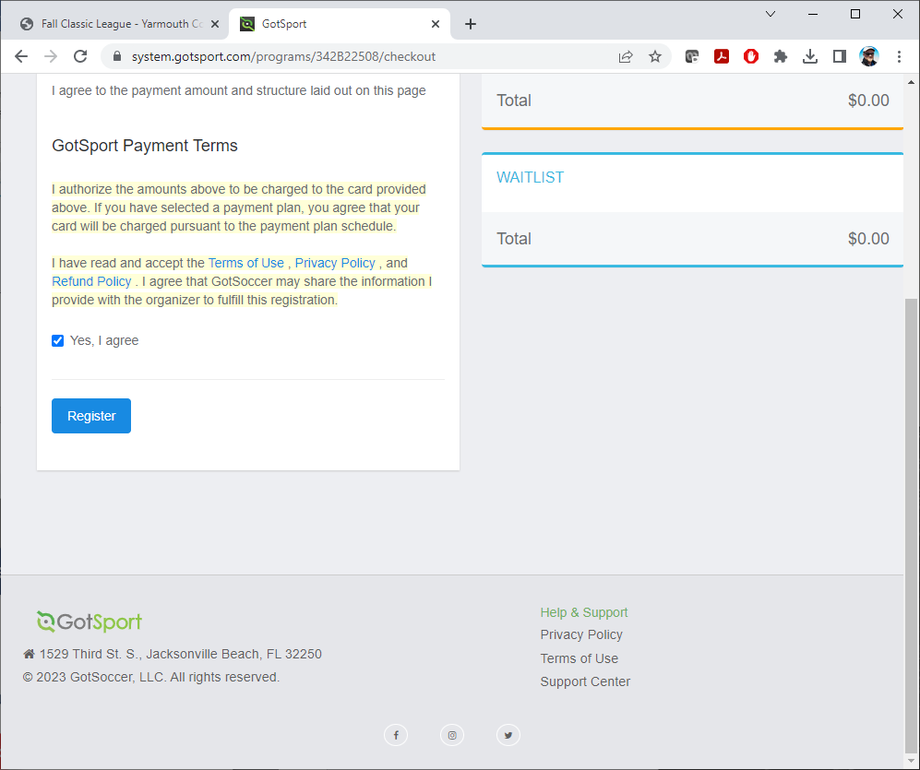
This pop-up comes up… to close, click on the top right “X”.
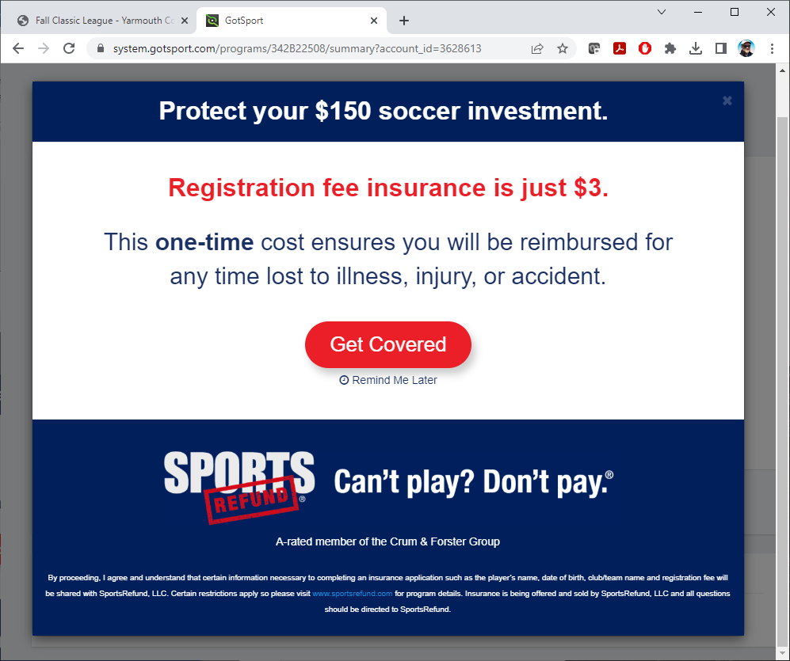

When the pop-up is closed, it brings you to the summary page, click on “Continue to My Account” on the bottom right to complete the process

It will bring you to your profile page in system.gotsport.com. To exit/logout, click on the silhouette on the top right and click on “Logout” from the drop down.
You will get a confirmation email that contains details regarding uniforms. PLEASE READ CAREFULLY.
If you run into any problems, or have any questions, please let the Registrar know. They will walk you through and find a solution to ensure your child is playing soccer with the Yarmouth Colts Soccer Club!
Thank you!
Registrar
Yarmouth Colts Soccer Club
registrar@yarmouthcolts.com

