Colts Fall Classic League – New Player Registration

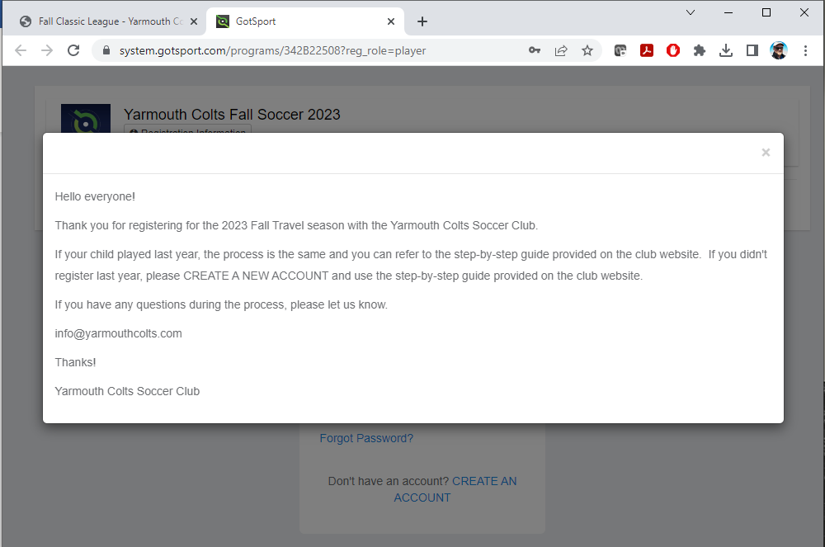

Click on the “X” on the top right

Since new to Colts, will need to create an account, click “CREATE AN ACCOUNT”

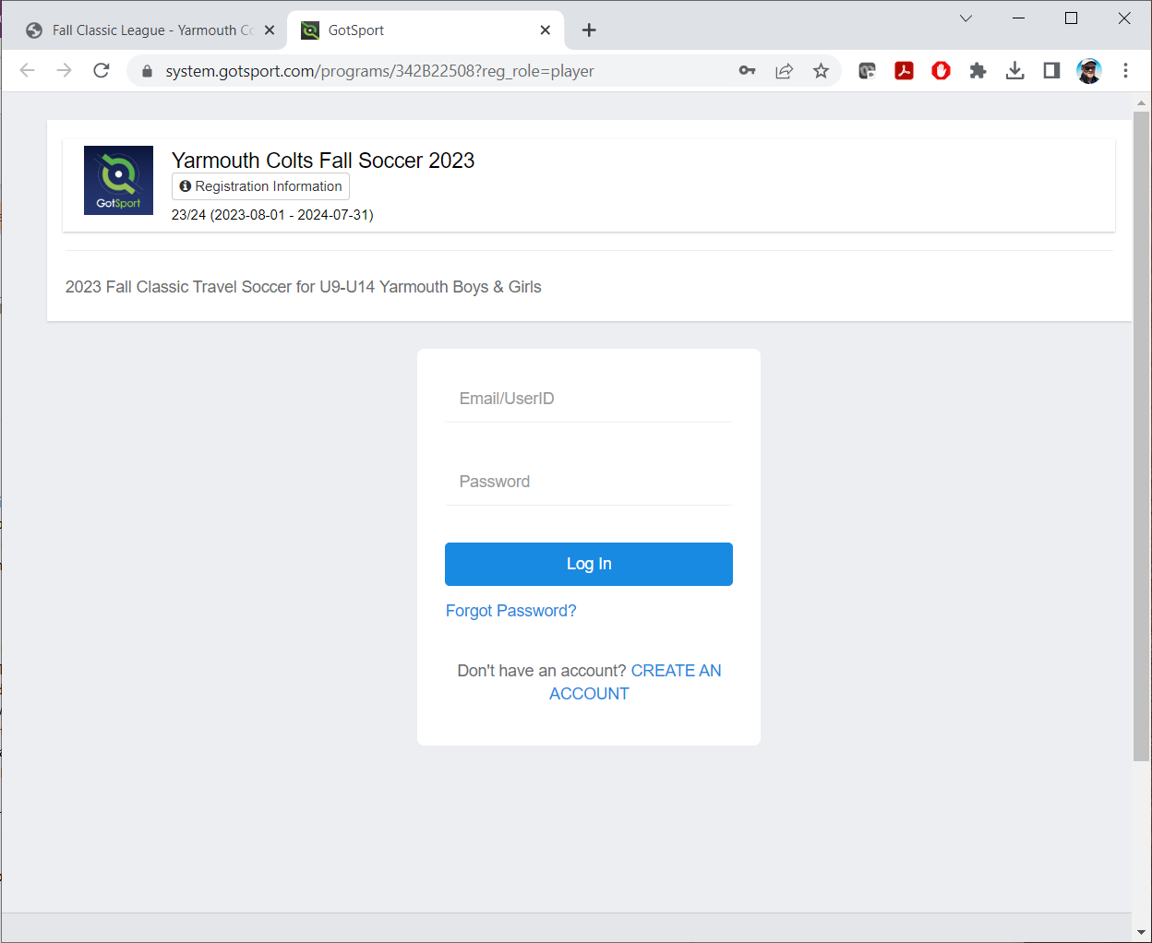

Click on “I’m registering my child or someone else”.
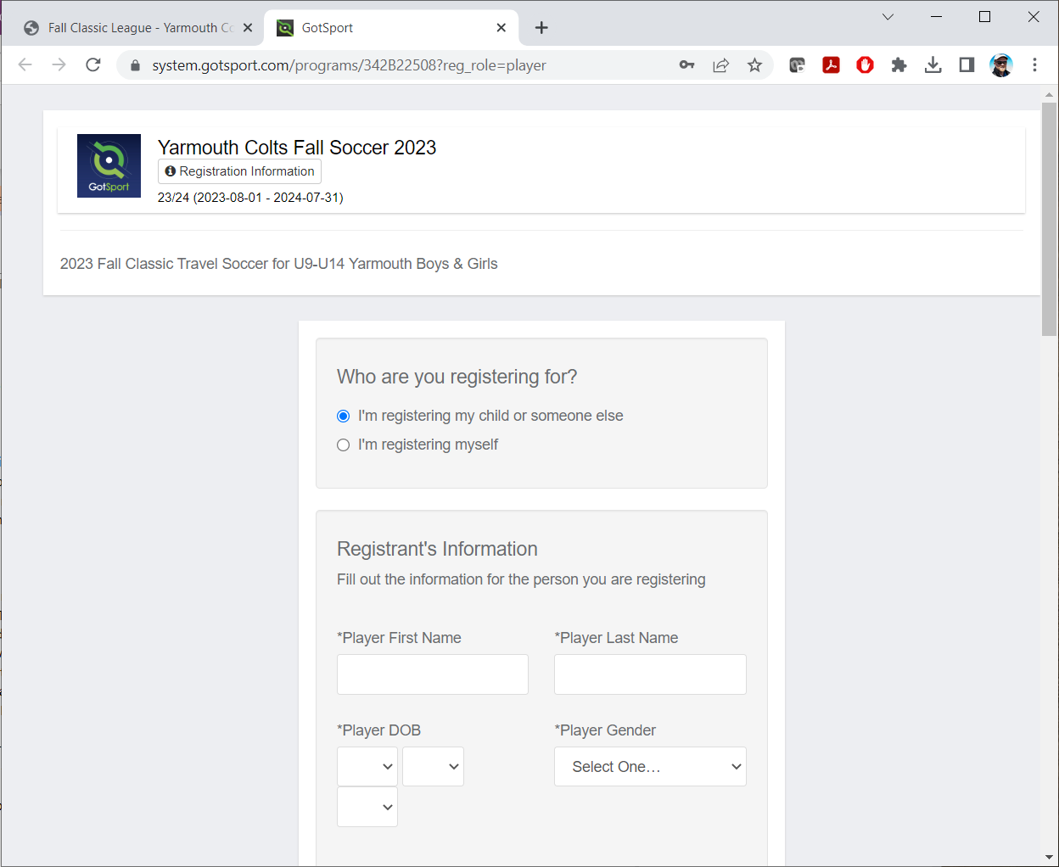

Enter the information, double check that it is all correct to prevent account errors.
“Registrant’s Information” is for the PLAYER
“Your Information” is for the PARENT/GUARDIAN
Make sure to select a “State/Province” from the drop down
Username will be email address, click “Sign up”

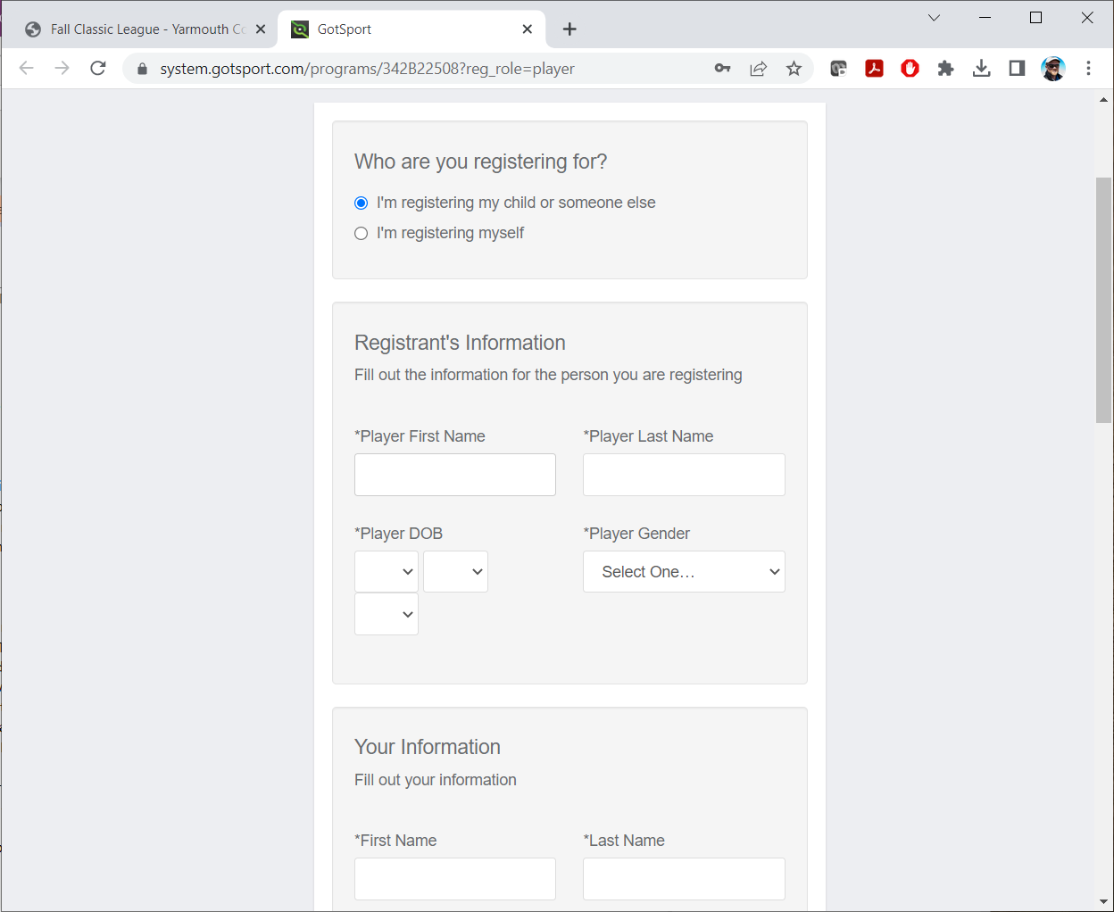
Your player’s info!
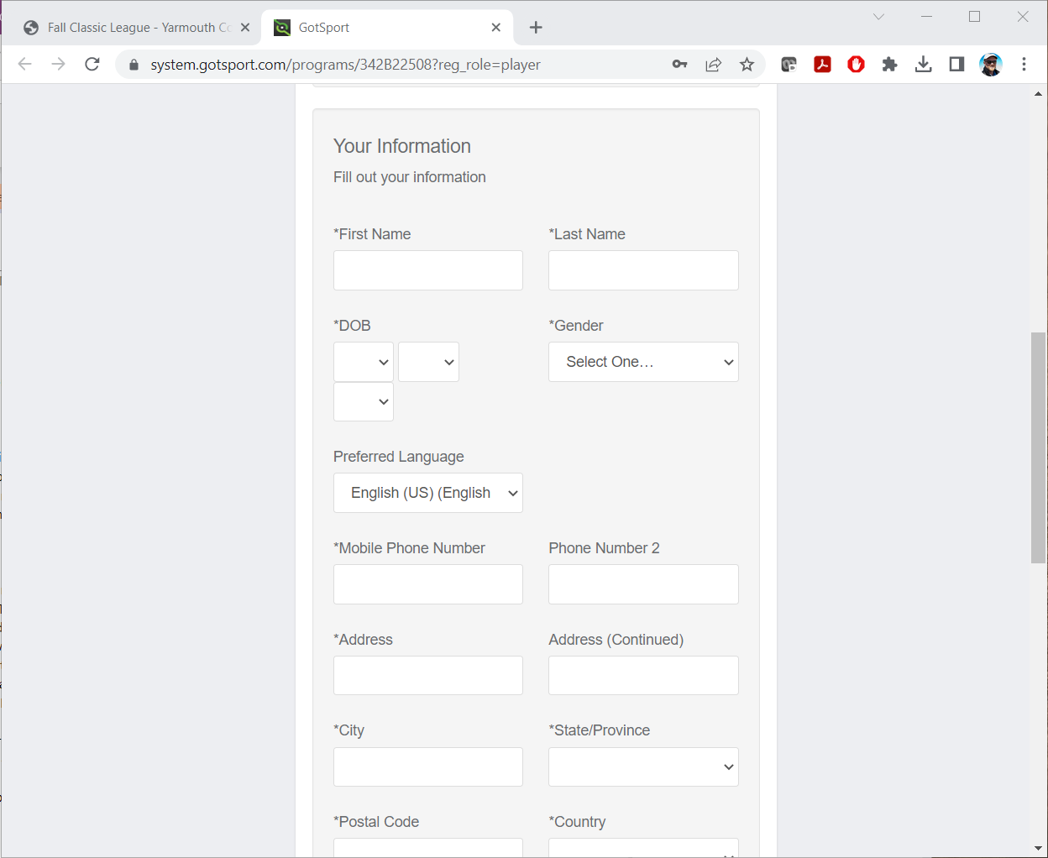
Your info!

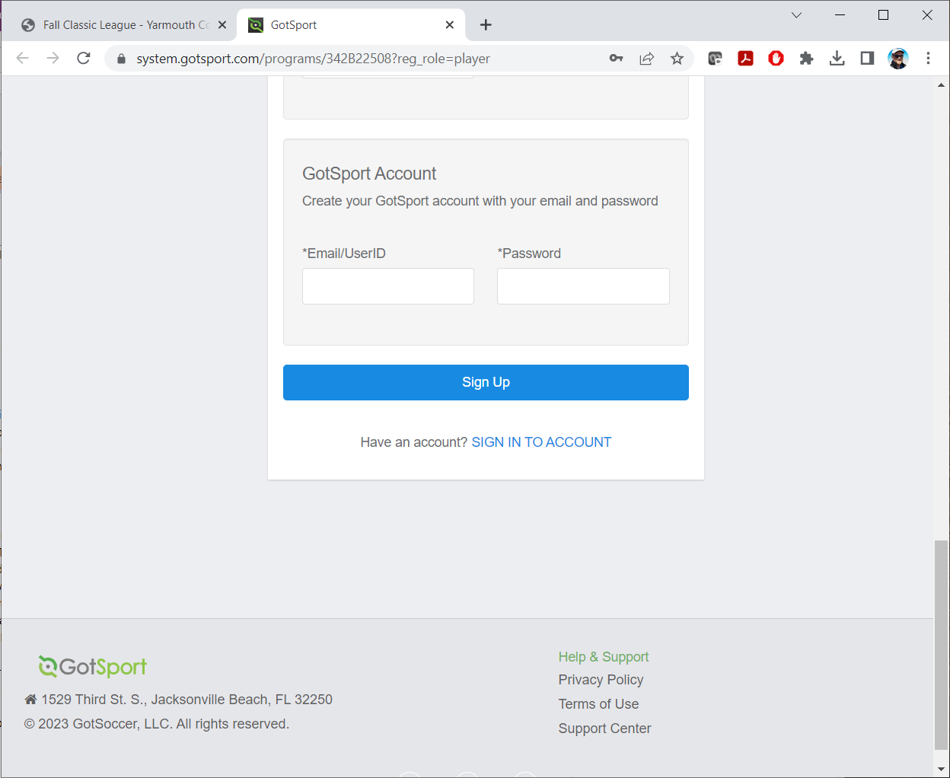

Brings you to the main page of the registration process.
Click next to the players name and click on “Register” and select “Player” from the drop down
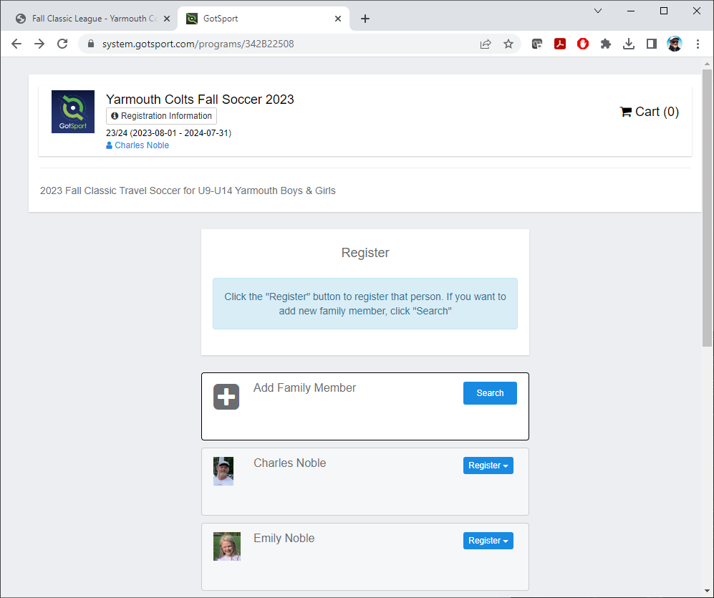

Please make sure the information is correct and click “Save” on bottom left.

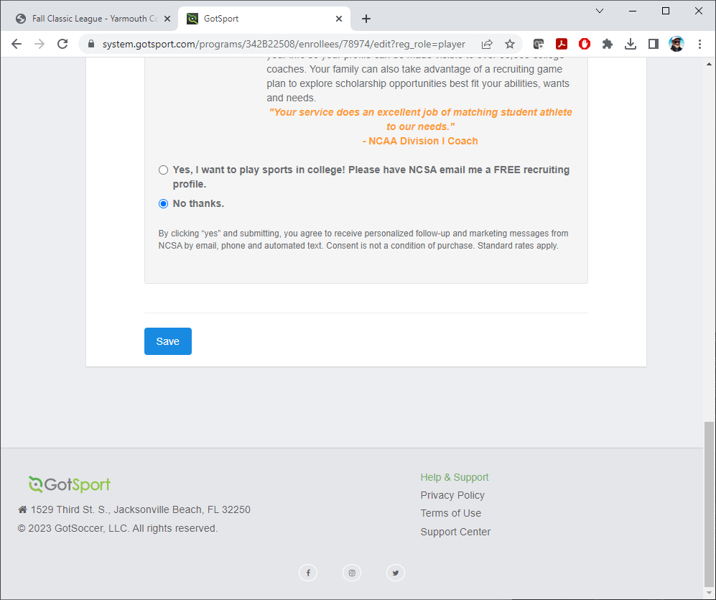

If you would like to add a Parent/Guardian, please click on “Select” next to “New user”, otherwise click on “Continue” on the bottom right.

Enter Emergency Contact information, please make sure this is accurate, click “Continue” on bottom right.

Please enter any other relevant information and sign electronically and click “Save (Page 1 of 1)” on bottom right.

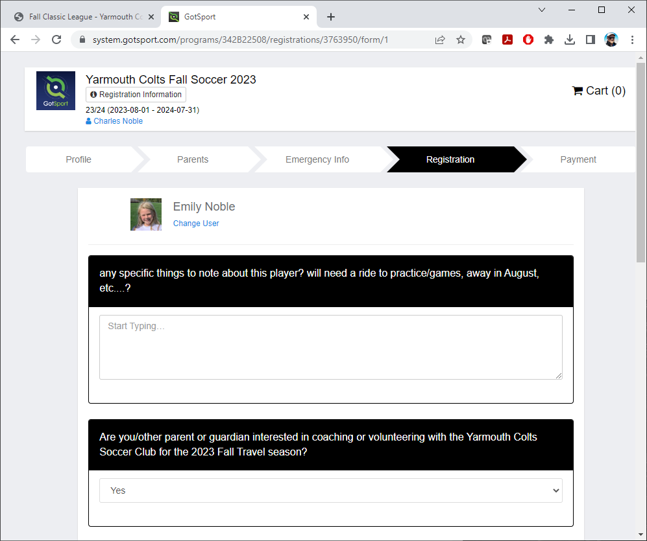

For the payment information, please verify it looks correct, click “Select”.

To confirm selection, please click “Checkout”

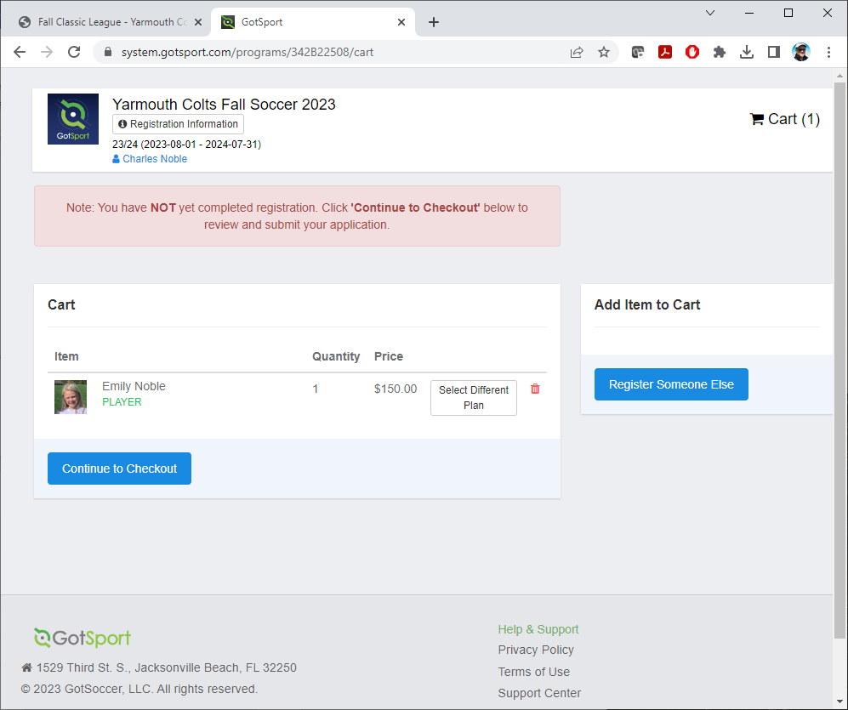

For payment options, you can either select Credit Card or Money Order/Check, please click “Yes, I agree” and the bottom will change from “Pay” to “Register”.

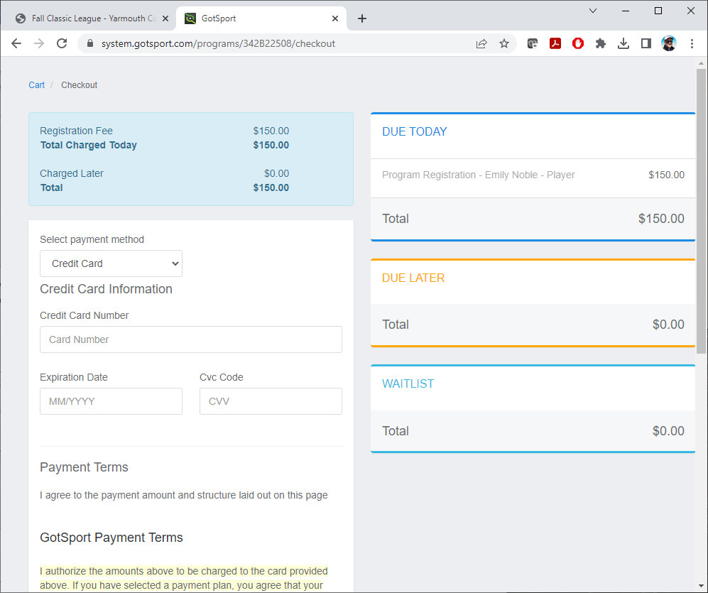

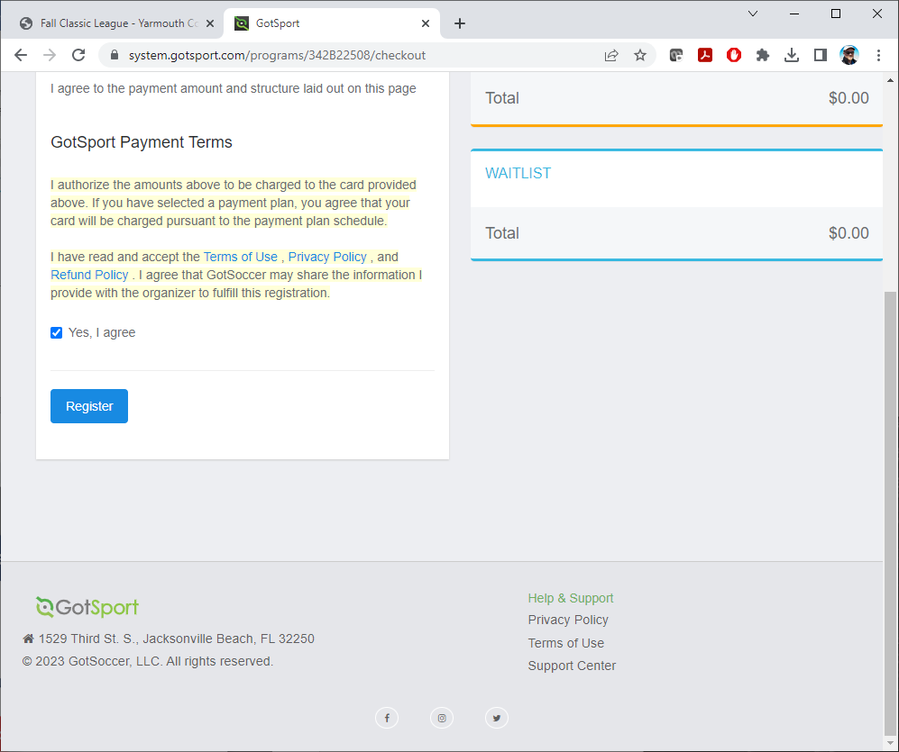

This pop-up will show, please click on top right “x” to close it

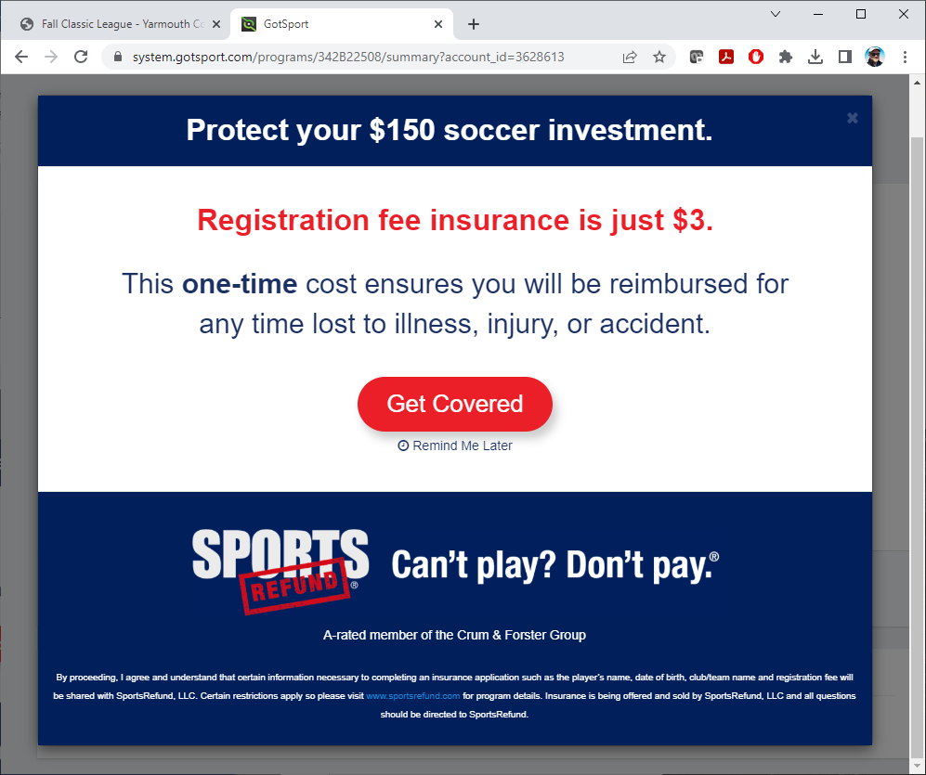

This provides you a summary of the registration.
Click on “Continue to My Account” to complete the transaction

This brings you to the home page of your system.gotsport.com account.
To exit/logout, please click on the silhouette on the top right and click on “Logout” from the dropdown

You will get a confirmation email that contains details regarding uniforms. PLEASE READ CAREFULLY.
If you run into any problems, or have any questions, please let the Registrar know. They will walk you through and find a solution to ensure your child is playing soccer with the Yarmouth Colts Soccer Club!
Thank you!
Registrar
Yarmouth Colts Soccer Club
registrar@yarmouthcolts.com

