https://system.gotsport.com/programs/51722525C?reg_role=player

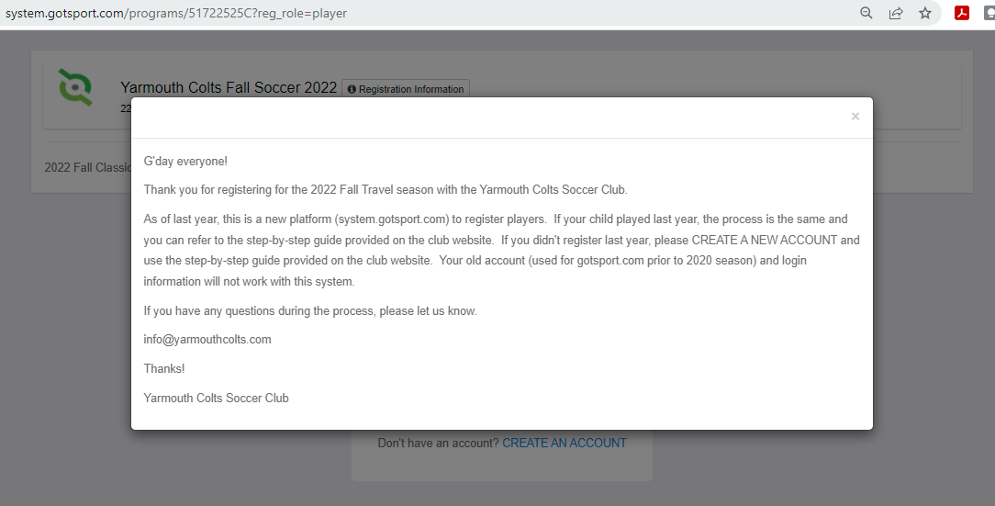

Click on the “X” on the top right

Since new to Colts, will need to create an account, click “CREATE AN ACCOUNT”

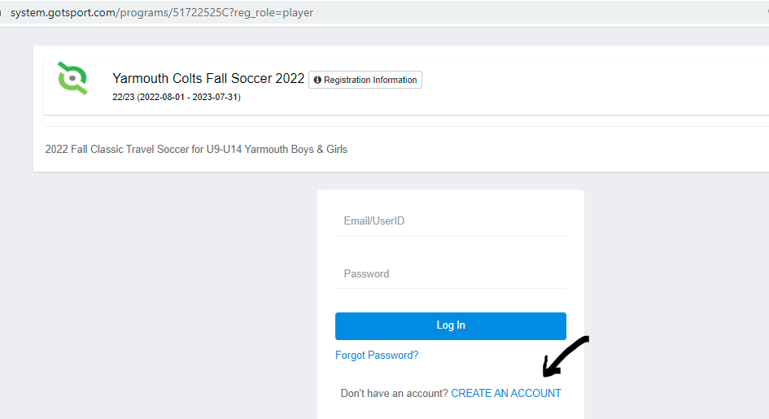

Click on “I’m registering my child or someone else”
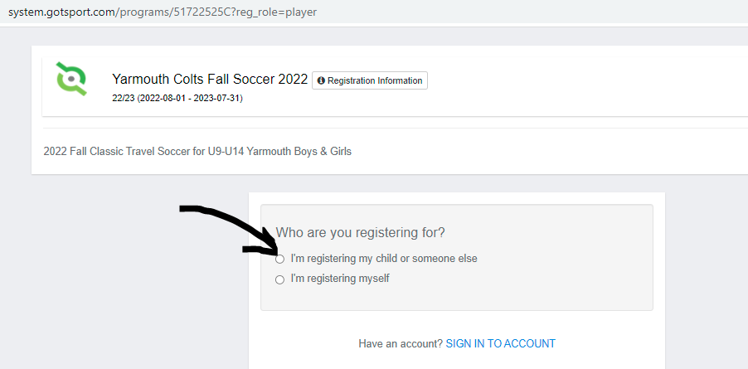
Enter the information, please make sure it is accurate and correct
“Registrant’s Information” is for the PLAYER
“Your Information” is for the PARENT/GUARDIAN
Make sure to select a “State/Province” from the drop down
Username will be email address, click “Sign up”
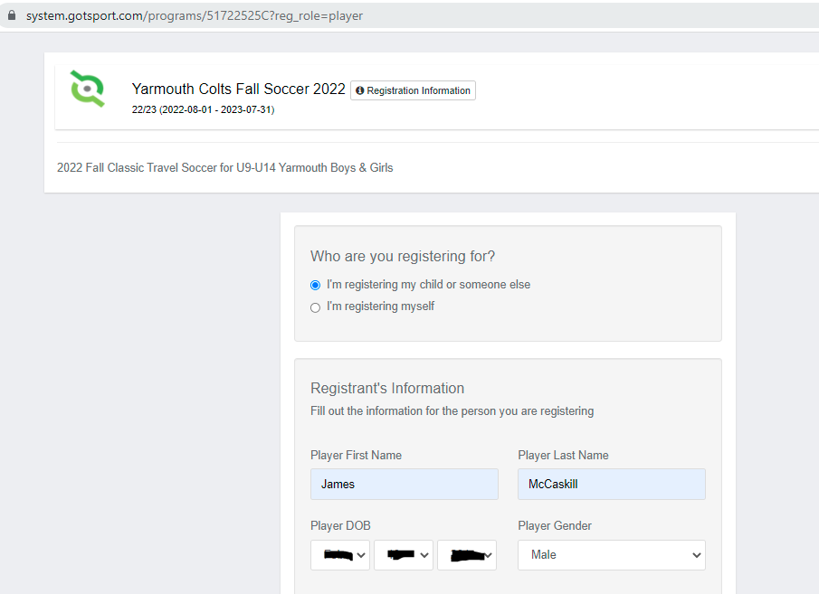
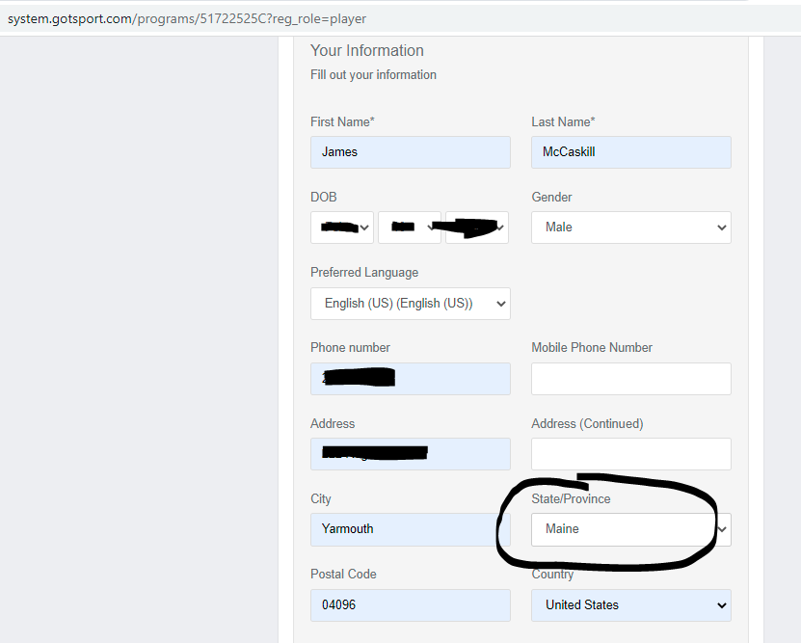
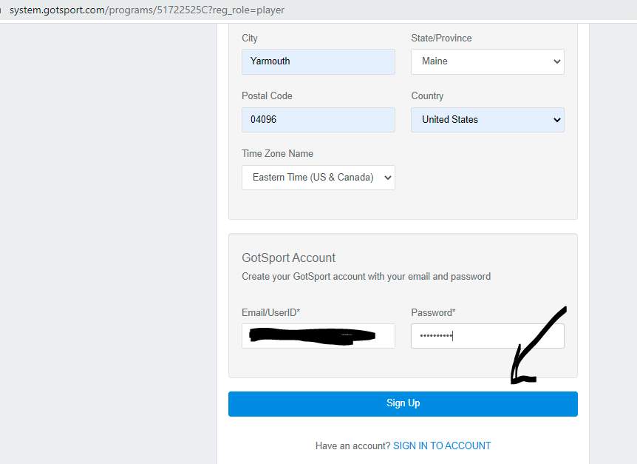
Brings you to the main page of the registration process
Click next to the players name and click on “Register” and select “Player” from the drop down
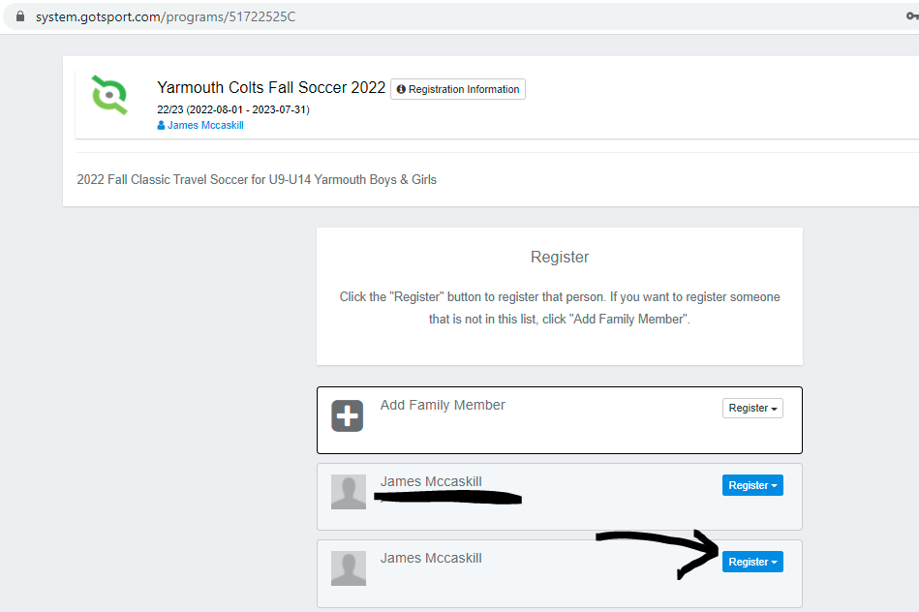
Please make sure the information is correct and click “Save” on bottom left
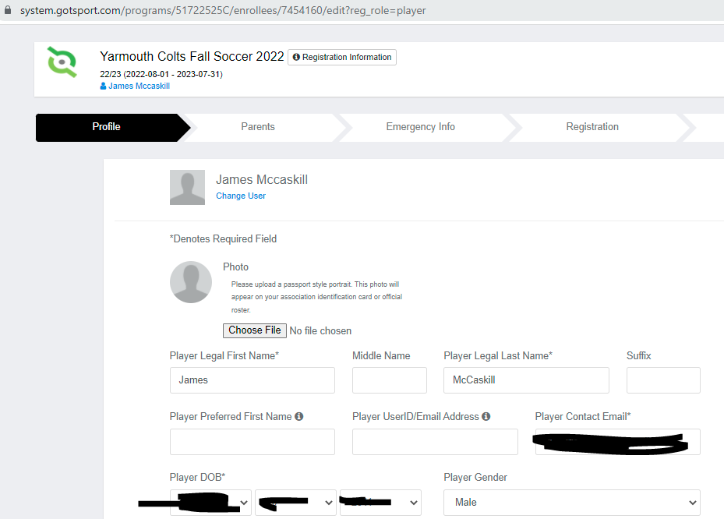
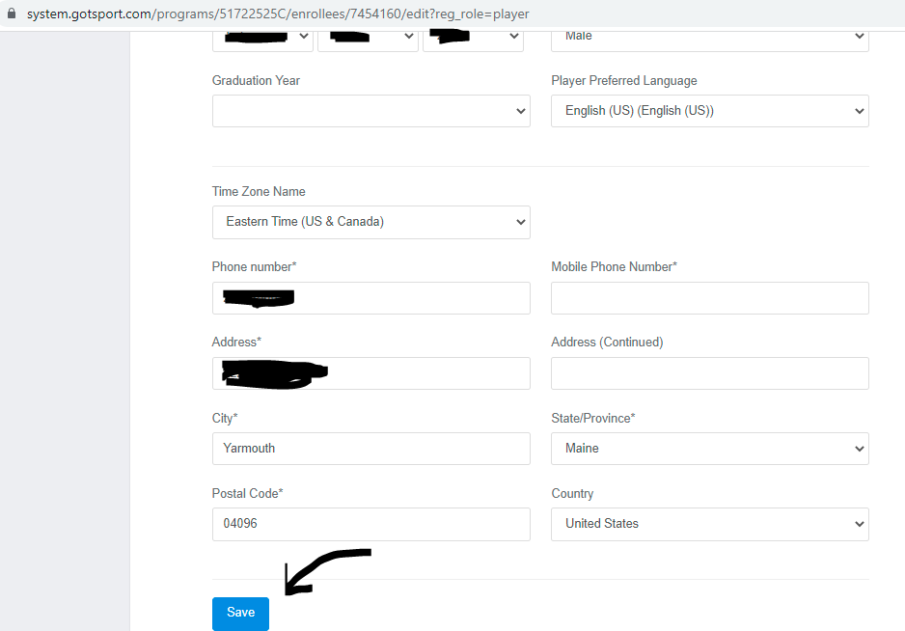
If you would like to add a Parent/Guardian, please click on “Select” next to “New user”, otherwise click on “Continue” on the bottom right
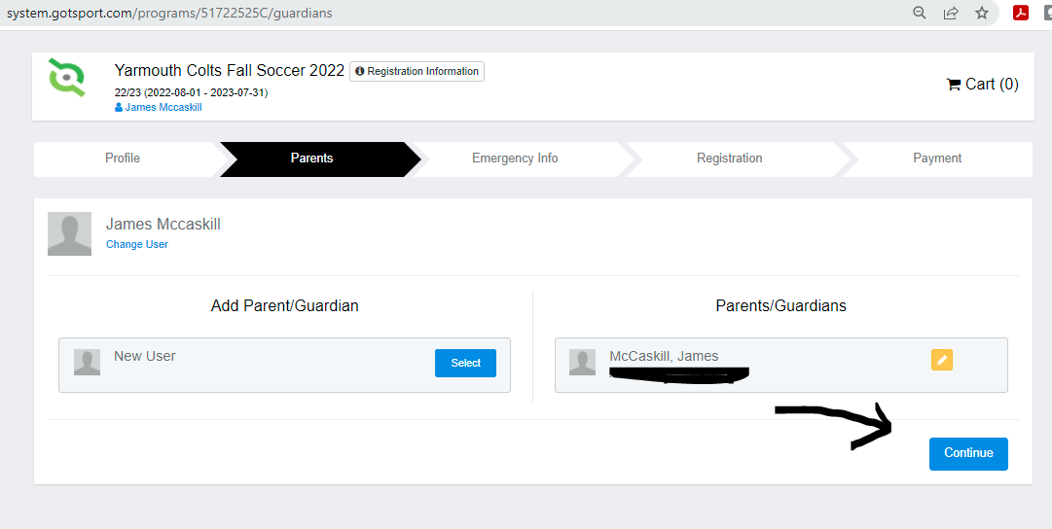
Enter Emergency Contact information, please make sure this is accurate, click “Continue” on bottom right
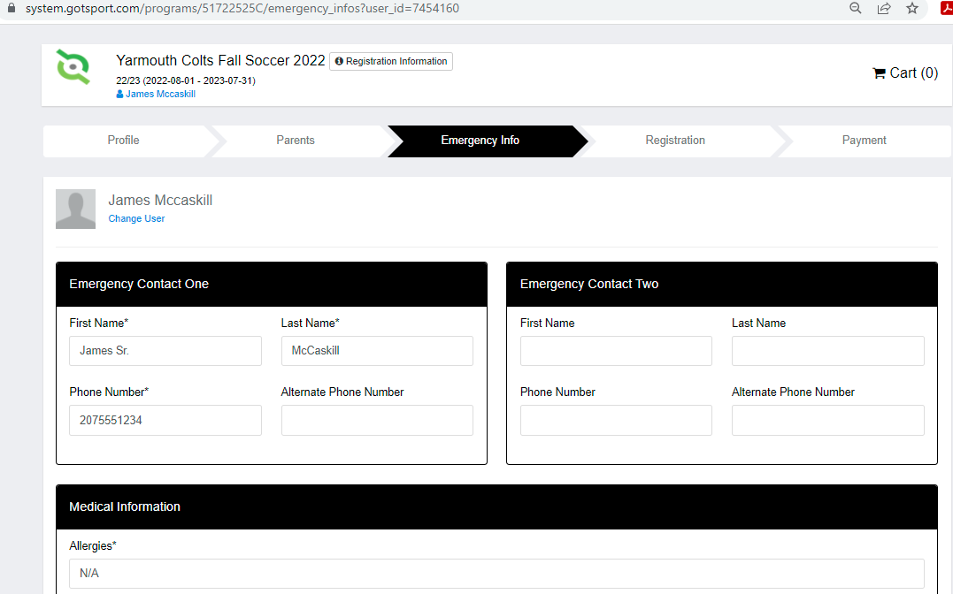
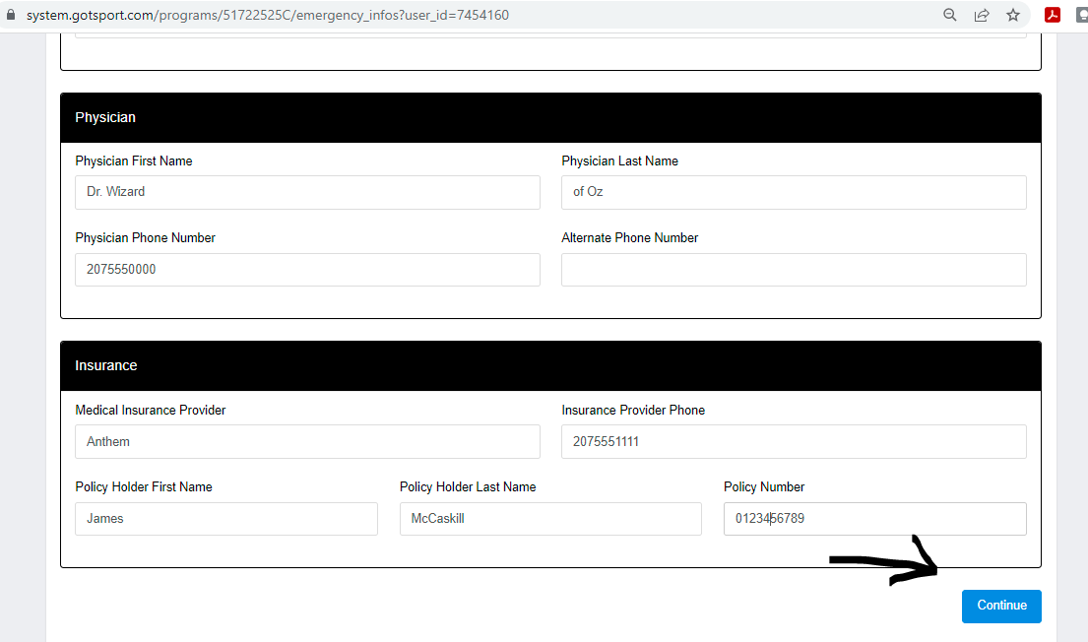
Please enter any other relevant information and sign electronically and click “Save (Page 1 of 1)” on bottom right
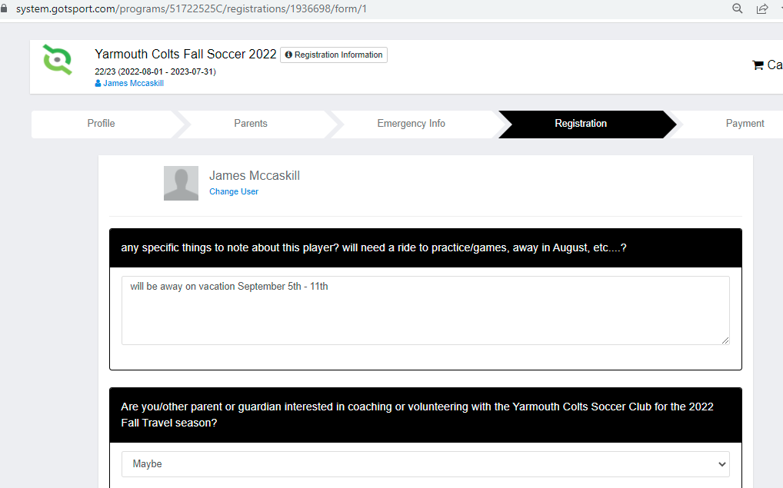
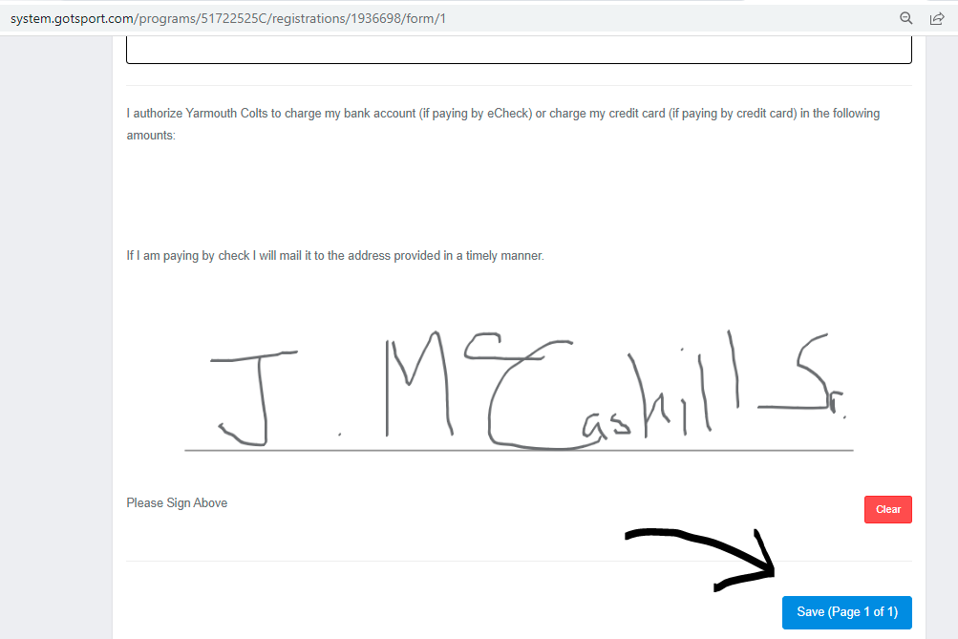
Please complete the waivers and medical release forms (actual waivers may be different than ones listed below) and click “Continue” at the bottom right
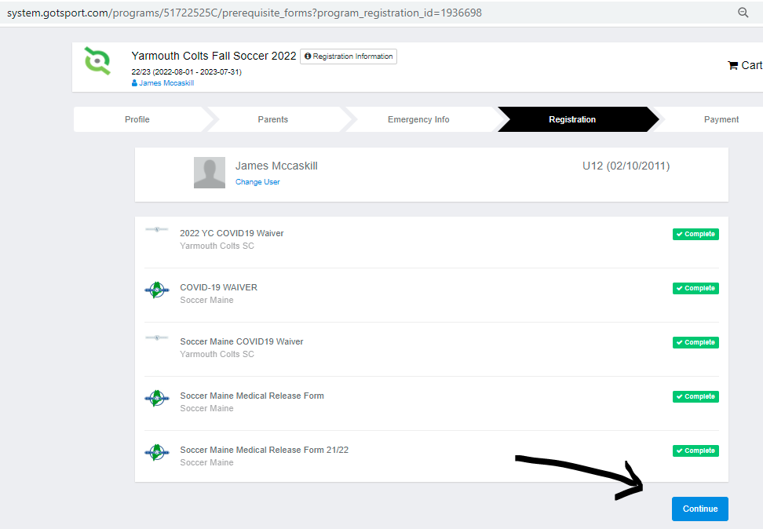
For the payment information, please verify it looks correct, click “Select”
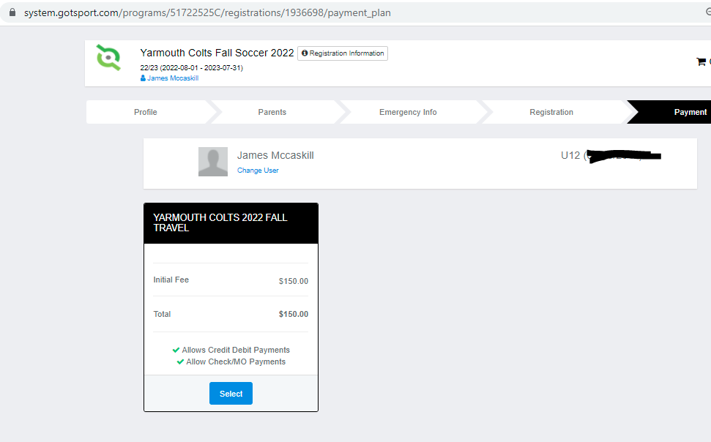
To confirm selection, please click “Checkout”
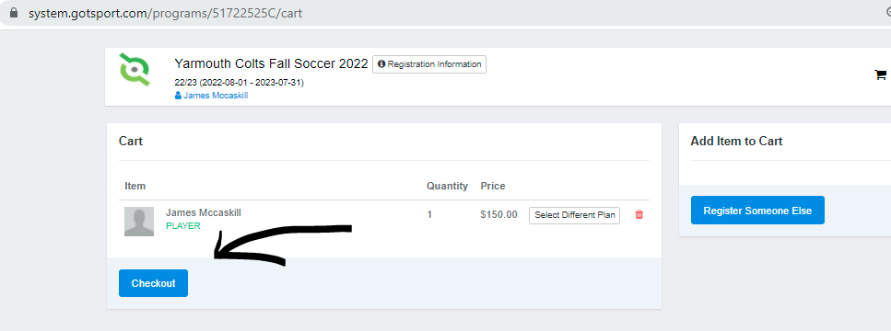
For payment options, you can either select Credit Card or Money Order/Check, please click “Yes, I agree” and the bottom will change from “Pay” to “Register”
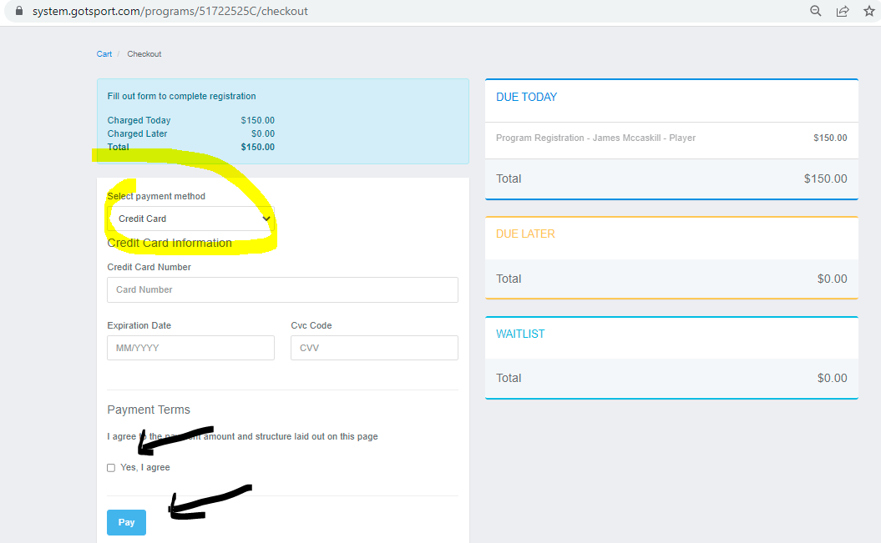

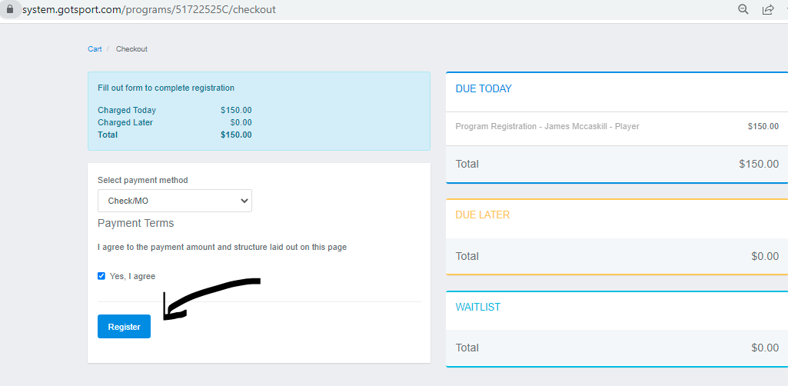
This pop-up will show, please click on top right “x” to close it
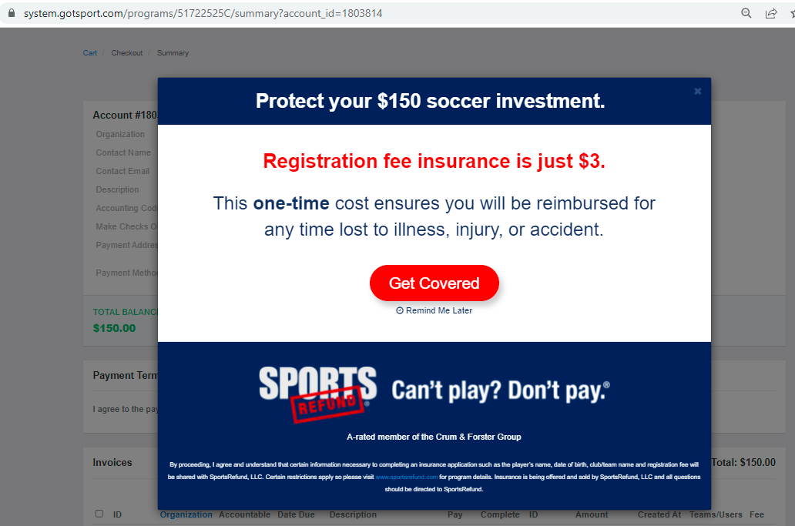
This provides you a summary of the registration
Click on “Continue to My Account” to complete the transaction
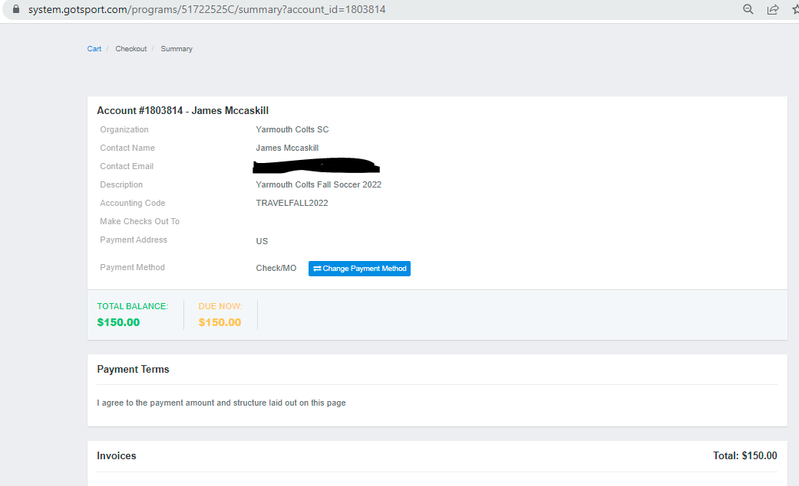
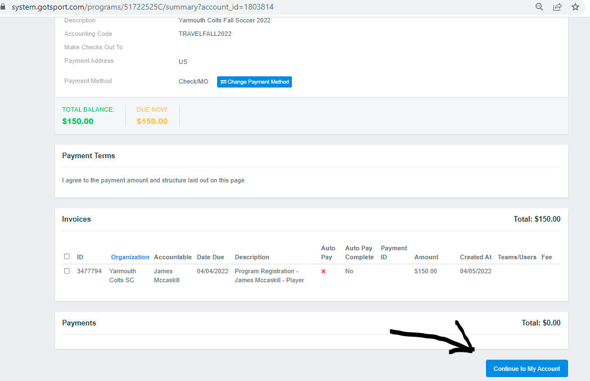
This brings you to the home page of your system.gotsport.com account
To exit/logout, please click on the silhouette on the top right and click on “Logout” from the dropdown
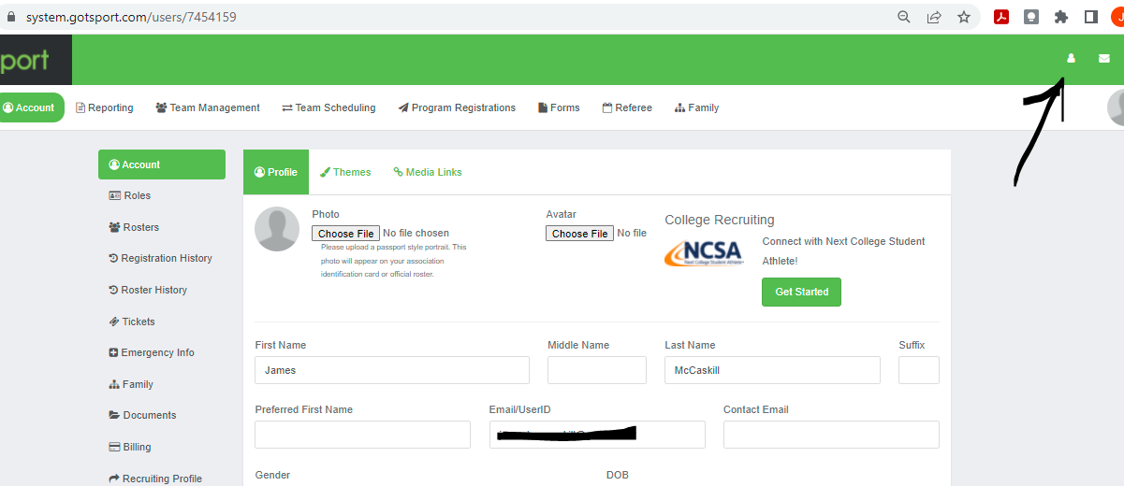

You will get a confirmation email that contains details regarding uniforms. PLEASE READ CAREFULLY.
If you run into any problems, or have any questions, please let me know. I will walk you through and find a solution to ensure your child is playing soccer with the Yarmouth Colts Soccer Club!
Thanks!
James McCaskill
Registrar
Yarmouth Colts Soccer Club
registrar@yarmouthcolts.com
info@yarmouthcolts.com

